**Configure RIPv2**

|  |
| --- |
| In RIPv2, you need to write direct connected networks within your routers.  List of total networks:   * 10.0.0.0 * 20.0.0.0 * 192.168.10.0 * 192.168.20.0 * 192.168.30.0   Now adding all these networks to all the routers.  **Configuring Router R0:**    **Configuring Router R1**:    **Configuring Router R2**: |

**OSPF (Open Shortest Path First)**

* Enter networks connected to every router directly.

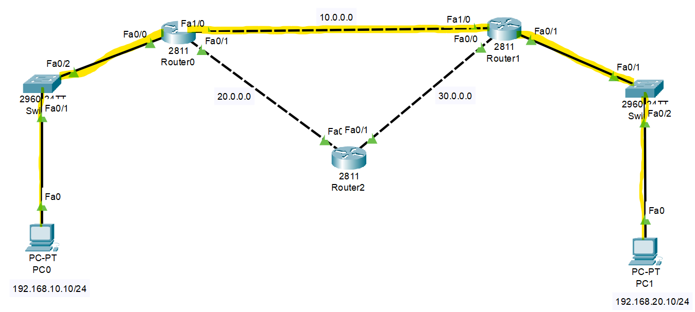

Syntax: **#network <network-range> <wildcard> <area> 0**

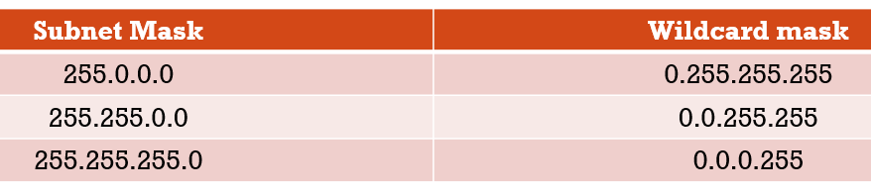

**Configuring Router R0**:

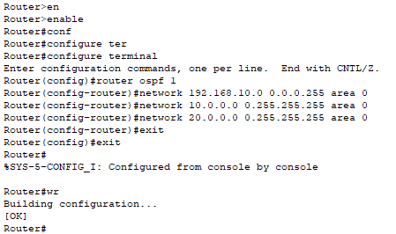

**Configuring Router R1**:

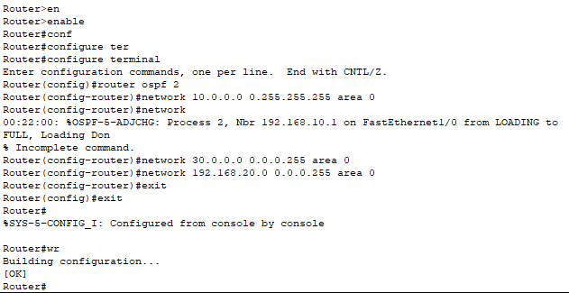

**Configuring Router R2**:

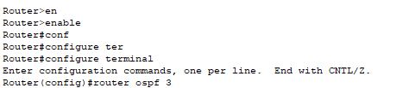

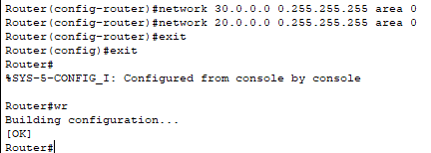

**EIGRP (Enhanced Interior Gateway Routing Protocol)**

Steps:

1. Becoming neighbor.
2. Exchange routing info.
3. Choose best route.

Condition to become neighbor

* Autonomous System number (AS) must be same.
* Subnet must be same.
* Authentication.

Here, only directly connected networks.

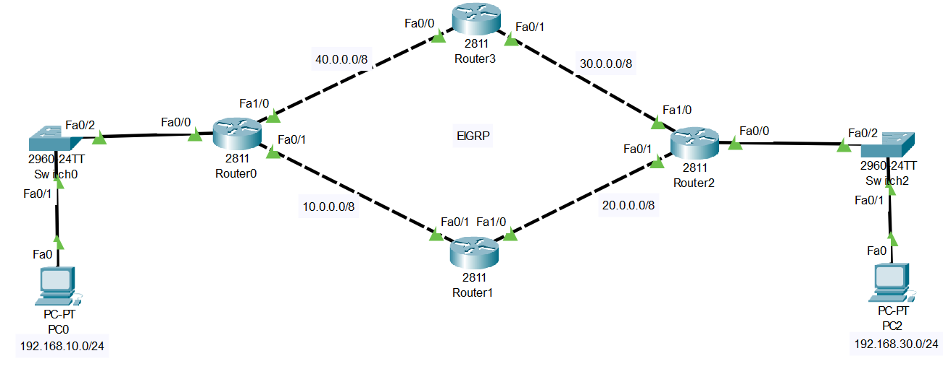

**Configuring Router R0**:

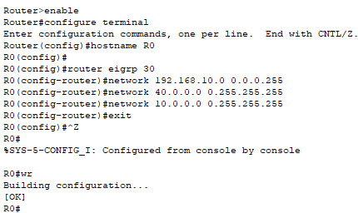

**Configuring Router R1**:

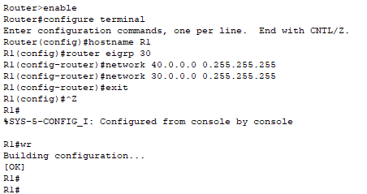

**Configuring Router R2**:

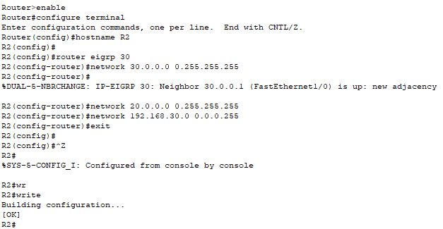

**Configuring Router R3:**

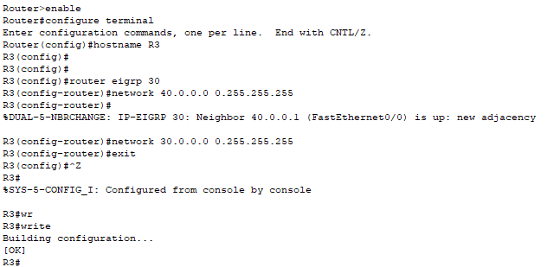

**ACL**:

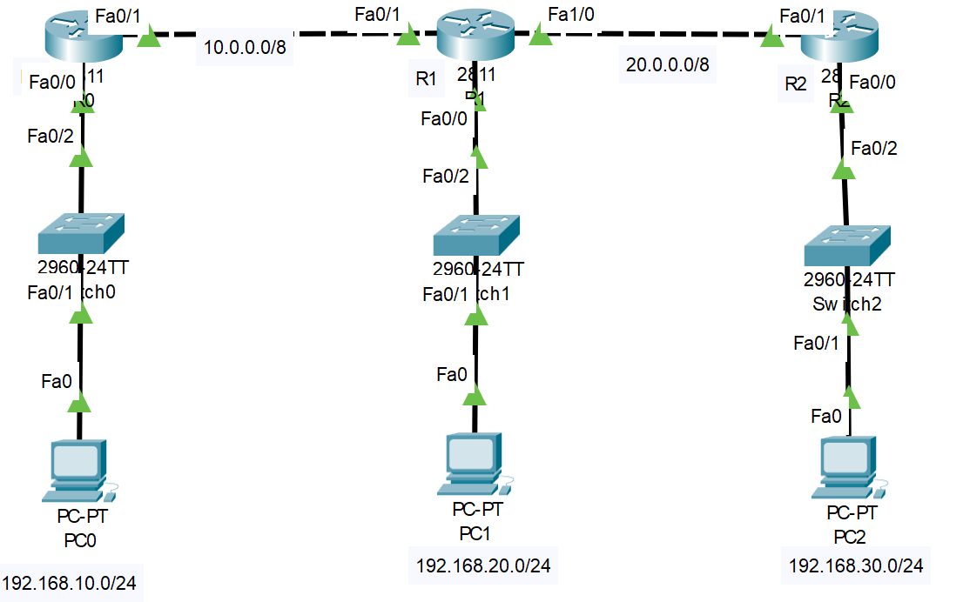

Without ACL, PC0 will ping PC2 using any routing protocol.

With ACL, PC0 will ping PC1 but PC0 will not ping PC2

**Applying ACL on router R2.**

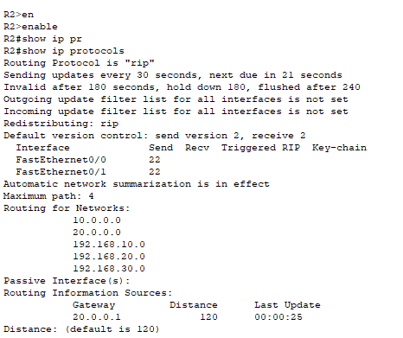

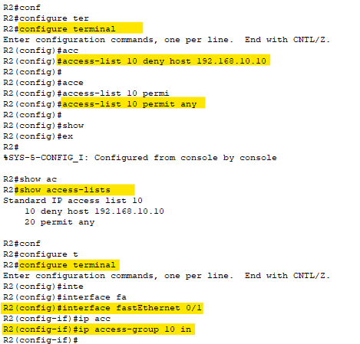

After pinging:

